Test user 1
lardiles@mail.edu.yu
leandroYU
leandTRADING123!

Test user 2
username='testuser',
email='test@example.com',
password= testpass123
name='Test User',
balance=Decimal('5000.00')

Backend

Frontend
Npm start
Issue 1: no pricing API on the backend

Implemented: yfinance

Issue: holdings page was not using finance so it was not showing current price:

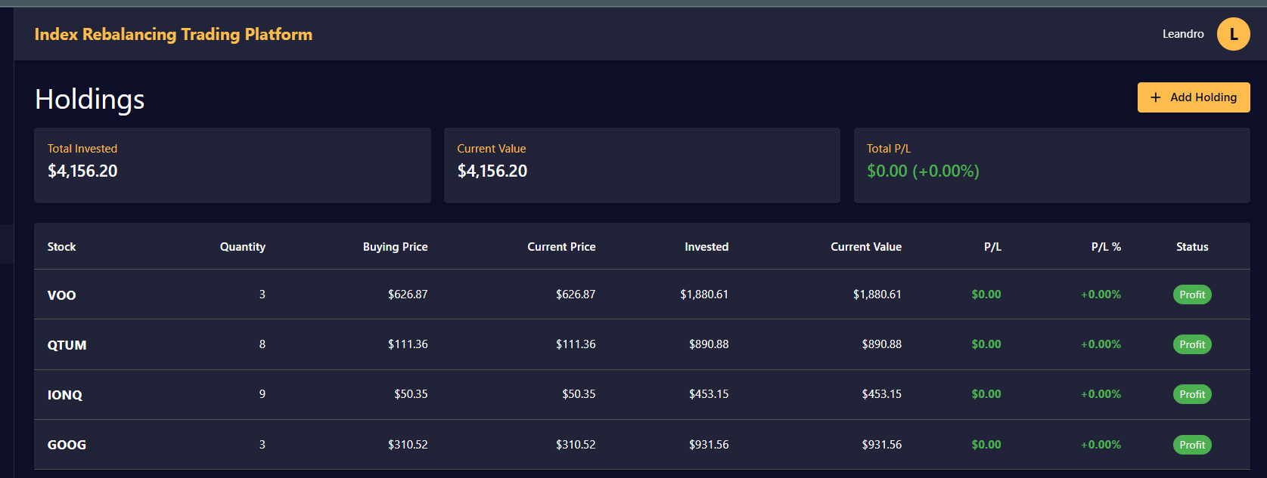
Idea: asset allocation dashboard:

This helps a trader define the mix and percentage of his portfolio allocation. For example, 10% in bond, 20% in commodity such as gold and energy, 20% in emerging markets, 40% in US equity, and 10% in crypto-currency and other alternatives.

- No pricing API on the backend..

From the book:
- Diversify stocks in US and China
- Invest in companies that have been there for more than 100 years: BNY Mellon (Ticker: BK), Consolidated Edison (Ticker: ED), Procter & Gamble (Ticker: PG), Colgate-Palmolive (Ticker: CL), JPMorgan Chase (Ticker: JPM), Coca-Cola (Ticker: KO), General Electric (Ticker: GE), Pfizer (Ticker: PFE), Ford (Ticker: F), and ExxonMobil (Ticker: XOM),
- S&P index is the better long term investment vehicle
- Quantum companies
- Environmentally friendly
- Companies who join an index!

From uninformed to informed traders

Buy-and-hold investor
Index investing with re-balancing

set a risk limit as a percentage of the book on each investment.

Define asset allocation goal.
This helps a trader define the mix and percentage of his portfolio allocation. For example, 10% in bond, 20% in commodity such as gold and energy, 20% in emerging markets, 40% in US equity, and 10% in crypto-currency and other alternatives.

